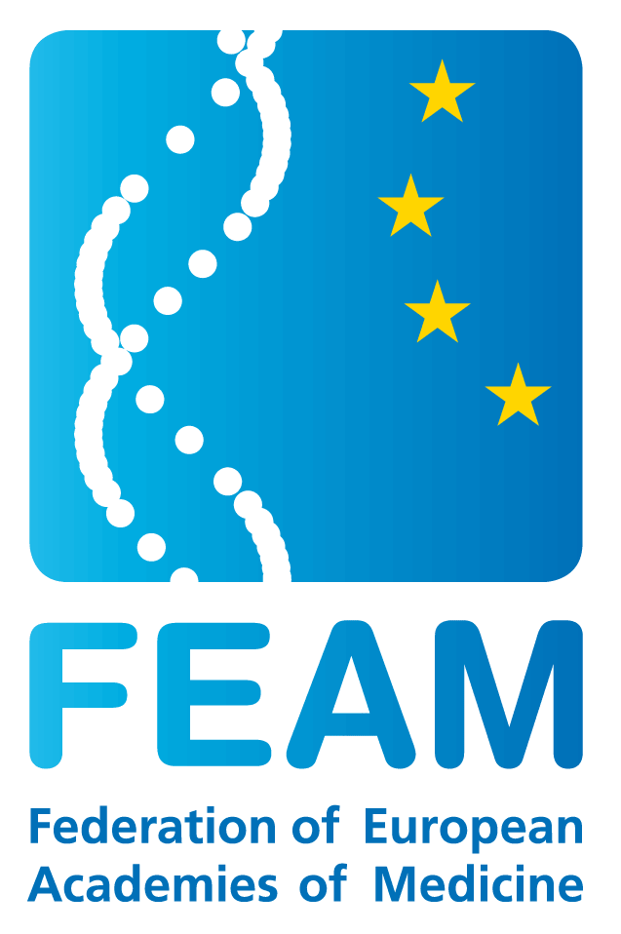

Key points from a meeting with DG Sanco (16 December 2013, Brussels)
Attendance: Dr. A. Rys, Dr. T. Piha, Dr. K. Hanslik (Sanco), Prof. J.A.F. Tresguerres, Prof. I. Popescu, Prof. R. Rokyta, Dr. R. Fears, L. Legros (FEAM)

- The conclusion from a discussion on the EU Health programme is that FEAM should apply again next year for an operating grant. It should seek to engage with the executive agency in Luxembourg to obtain all the background information but also perhaps with organisations that have been successful (pages 11-12). The focus of next year’s programme will be health systems and the legislative agenda so, following FEAM’s sustained engagement on EU regulations, next year’s focus would be more in line with FEAM’s strengths. Dr. Rys had read the recent QJM commentary on data protection with attention.
- The data protection regulation will be further discussed on 8-10 January 2014 by the European Council and now is the time to keep informing national decision-makers. Heads of Governments would like this regulation to be ready by January 2015, in which case this European Parliament should finalise it. If this does not occur, the dialogue should start again in September 2014.
- Results on progress made on the Clinical Trials Regulation are expected this Friday or in early January 2014. All information is available on the ENVI committee web page.
- The EU tobacco directive was being finalised this week (EC/EP/ECouncil compromise). The issue of electronic cigarettes is sensitive (a consumer’s issue or a pharmaceutical product?), scientific evidence is lacking and a good debate is needed. FEAM’s input would be useful.
- Personalised medicine will remain high on the agenda and a report was published in October 2013 as a review of the situation. It remained difficult to reach any definitive conclusion or make specific recommendations regarding possible changes in the legislation or in the research agenda at this stage. Yet Personalised Medicine is well covered by Horizon 2020. Waiting to see how in-vitro diagnostic legislation (and CTR and data protection) will play out is required.
- Healthy ageing will remain another priority of Sanco for the coming financial perspective. Prof. Tresguerres noted his link with the European Platform for Health Ageing, his attendance of their 25 November 2013 conference. Dr. Rys highlighted that further evidence from Eastern countries, especially with regards to geriatrics as a specialty, was lacking and would be useful to obtain through FEAM Academies.
- FEAM could consider responding to the public consultations on risk-assessment
- Antimicrobial resistance was noted as well as the issue of vaccination as (global) priorities. A recently published report on flu vaccination highlights a decreased intake. The recent issue with polio in Syria was also noted.
- When bringing up the FEAM ethical review workshop, it was noted that knowledge sharing between the ethics committee falls within the remit of DG Research. Yet DG Sanco is responsible for the CTR and FEAM will invite a representative of Sanco. A position statement published by the University of Heidelberg in the context of a project ‘Ethical and Legal Aspects of the Whole Genome Sequencing’ (EURAT) was highlighted by Dr. Rys. They have been working on questions concerning normative and legal issues, and economic aspects of genome sequencing for two years. They identified problems, developed a basic agreement on how to handle the questions raised by whole genome sequencing in translational research. This resulted in a code of conduct for non-physician scientists involved in whole genome sequencing and informed consent models.
- Membership of the EU Health Policy Forum will be discussed in the coming months and there should be a new opportunity for FEAM to apply. This was later confirmed by Karolina Hanslik (Sanco policy officer). Sanco in Luxembourg is supporting this Forum.

